**Leader Overview**

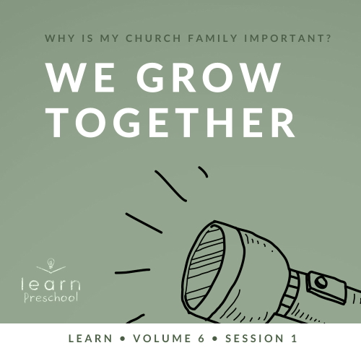

**Volume Overview**

**Why is my church family important?**

*When we think of church, it’s easy for our mind to be instantly drawn to the building where we attend. However, in God’s design, the church isn’t the building that we gather in. Instead, church has everything to do with the people who are gathered there. In essence, the biblical church is not a building that we go to but a family of believers that we belong to*.

*As our Father, God’s heart is to adopt us into His family (*[*Ephesians 1:5*](https://ref.ly/logosref/Bible.Eph1.5)*). When we choose to put our faith in Jesus, we instantly join God’s family. We not only belong to Him but we also belong to each other. Just like our natural families here on earth were meant to function, God uses our church family to meet our needs. A healthy church family offers love, encouragement, guidance, and accountability. As the family of God—the Church—we grow together, celebrate together, share together, and even serve together. As we make a commitment to God’s family, we will become stronger, more devoted followers of Jesus*.

**Session Overview**

**We Grow Together**

*In this* **Learn** *session, preschoolers will discover the importance of growing together in a church family. We’ll look at the Early Church in* [*Acts 2*](https://ref.ly/logosref/Bible.Ac2) *and learn from their example*. *Kids will discover at an early age that God desires for His people to gather together and live in community*.

**Bible Lesson**

Believers Grow Together

[Acts 2:42–47](https://ref.ly/logosref/Bible.Ac2.42-47); [Ephesians 5:17–20](https://ref.ly/logosref/Bible.Eph5.17-20)

**Faith Fact**

We grow together.

**Faith Verse**

[Matthew 18:20](https://ref.ly/logosref/Bible.Mt18.20) (NLT)

“For where two or three gather together as my followers, I am there among them.”

**Preparing for the Session**

**Leader Preparation Time: 20–25 Minutes**

|  |
| --- |
| ***You Will Need***  ***Preservice Activities***  *• Fake plant or* ***Bible Story Warm-Up Page***  *• Toys*  *• Cut up fruit and vegetables*  ***Large Group***  *• Bible*  *• Worship songs (Song suggestions: “Jesus Loves Me” (Remix) by Listener Kids; “The Lord Is My Rock” by Freedom Kids; “Nothing Is Impossible” by PlanetShakers Kids)*  *• For groups not using a phone or tablet only, add:*  *• Projector or TV*  *• Laptop*  *•* ***Faith Fact Sound*** *video (bell ringing)*  *•* ***Faith Fact Slide***  *•* ***Faith Verse Slide***  *•* ***Bible Lesson Video A***  *•* ***Bible Lesson Video B***  ***Small Group***  *• Blocks of different shapes or colors*  *• Measuring tape*  *• Optional: Painter’s tape*  *•* ***Small Group Activity Page****, one per kid*  *• Crayons, markers, or colored pencils*  *• Straws with paper wrapper, one per kid*  *• Small bowl of water, one per group*  *• Small paper plates, one per kid*  *To access session content and videos from a computer, visit:* [*BibleEngagementProject.com/downloads*](https://bibleengagementproject.com/downloads) |
| ***Getting Ready***  ***Preservice Activities***  *• Print the* ***Bible Story Warm-Up Page****.*  *• Set out toys and snacks.*  ***Large Group***  *• Download videos and slides if needed.*  *• Select worship song(s) and have them ready to play.*  ***Small Group***  *• Optional: Tape a square on the floor to mark the area to keep the blocks in. This will help to keep them from falling on someone or something.*  *• Print copies of the* ***Small Group Activity Page****, one per kid.*  *• Optional: Watch this video about the object lesson (*[*https://www.youtube.com/watch?v=mFI0RHvZUUA*](https://www.youtube.com/watch?v=mFI0RHvZUUA)*)*  *First time leading* Learn *for Preschool? Check out the* [Facilitator Guide](https://0b769b0ed3569ef9d18b-f88d8272f61086866d50d048b43ef630.ssl.cf2.rackcdn.com/sites/biblengagementproject/Listen_Facilitator_Guide.pdf). |

**Preservice Activities**

*See what’s needed at the beginning of the session.*

**Bible Story Warm-Up**

*As kids enter the room, have them sit in a circle*.

I’m so excited that you’re here today! *(Hold up plant or* ***Bible Story Warm-Up Page.****)* Does anyone know what this is? *(Allow responses.)* That’s right, a plant. Now who can tell me how plants grow? *(Allow responses.)* Wow, those are all great answers. Plants need dirt, water, and sunlight to grow.

What are some other things that grow?

Did you know that people grow?

What are some things that help us grow?

We don’t just grow by getting bigger and taller. We also grow in how we know and love God. What are some ways we can grow like that? *(Allow responses.)*

When we learn from the Bible and pray together, we’ll grow closer to God. Today, we’ll learn about different ways we grow, and how you and I play a part in that. I can’t wait to learn more with you.

**Snack**

**Plant Foods (Cut-up fruit or vegetables)**

*As kids are eating the snack, share the following:*

Isn’t it great that we can all share our snack together?

How would you have felt if you got less snack than everyone else?

How would you have felt if you got more than everyone else? What would you have done?

Did you know God wants us to take what we have and share it with others? We could share the actual things we own. We could also share what we know about God. Today, we’ll talk about how we can help each other grow.

**Free Play**

*Any extra time can be spent playing with toys*.

**Transition**

*A few minutes before service begins have kids make their way to the large group area and sit in their designated areas*.

**Large Group**

**25 Minutes**

*See what’s needed at the beginning of the session.*

**Introduction**

We’re going to have so much fun learning from God’s Word together. *(Hold up Bible.)* If you’re excited to be here, say, “Oh, yeah!” *(Group response)* Awesome! Today, we’ll discover why we have a church. I don’t mean the church building. Watch this finger play.

• *Do hand motions to “Here Is the Church” finger play: Here is the church, here is the steeple, open the doors, and see all the people*.

Have you ever seen someone do that before? *(Group response)* The Church isn’t the building we meet in. The Church is God’s people. Everyone who loves God and believes in Him is part of the Church. God knew we would need people to help us learn more about Him. In fact, we can help each other grow. For example, who is someone that helps you learn more about God? *(Allow responses.)* Those are great answers.

**Faith Fact**

You know, the more we talk about people who help us learn about God, the more it reminds me of our Faith fact. **We grow together**.

• *Show the* ***Faith Fact Slide***.

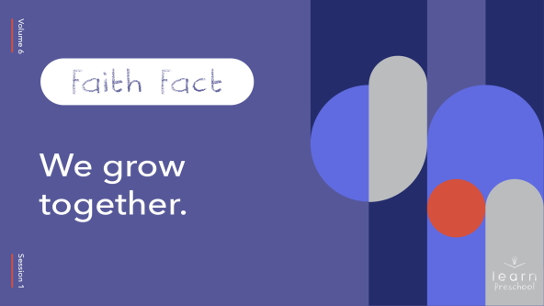

One way for us to grow together is to say our Faith Fact together. Let’s do it by pretending to grow each time we say it. Let’s start by getting down low to the ground. Ready? **We grow together**. Now, grow a little taller. **We grow together**. Let’s grow a little taller. **We grow together**. Let’s stand up as tall as we can. **We grow together**.

**Bible Time**

The Bible tells us how we can grow together. In fact, God gives us an awesome promise about this. Let’s watch this video and learn our Faith Verse with Lizzy.

• *Play* ***Bible Lesson Video A***.

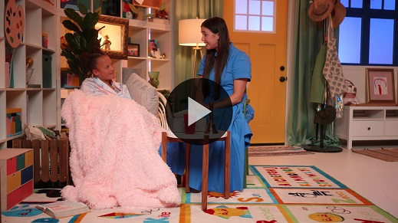

Wow! You did such a great job with today’s Faith Verse. I know it’s new, but you’ll have it memorized in no time. This verse is a great reminder that God is with us when we gather with our friends to worship Him. That’s why we’re learning this Bible verse together. It’s one way we grow together.

**Worship**

God is with us when we worship together. One way we help others grow during worship is to focus on God. When we focus on God instead of talking to our friends or looking around, we won’t distract our friends from worshipping God.

**Praise**

Do you want to thank God for your friends? Clap your hands three times. (*Group response)*

Are you excited to worship God with your friends? Jump up and down. *(Group response)*

Who wants to show God how much you love Him? Wave your hands up high. *(Group response)*

**Sing**

Let’s keep this praise going and worship God together. When we sing, it’s our chance to tell God how much we love Him.

• *Lead the kids in singing one or two songs. See song suggestions at the beginning of the session*.

**Prayer**

Wow! You all sounded so great together. I know God loves to hear you sing and worship Him. We just spent some time singing. Now, let’s be still and talk to God. Let’s bow our heads and pray.

|  |
| --- |
| Dear God, thank You for giving us friends and family who can help us learn more about You. Help us share what we know about You with others so that we can grow together. Amen. |

**Bible Time cont’d**

The Bible is one of my favorite things to read with friends. In fact, it’s one of the ways we grow together. You’re my friends. Let’s grow together as we learn from the Bible. Why don’t we see what Lizzy is up to?

• *Play* ***Bible Lesson Video B***.

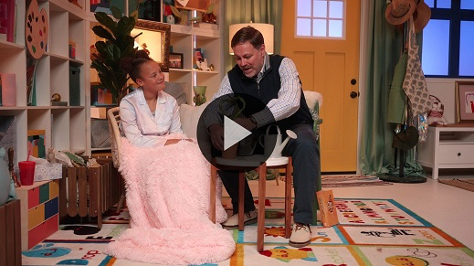

It was so awesome to learn how people in the Bible shared the things they had with each other. But they didn’t just share their things. They spent time together. The people would worship together, pray together, and even eat together. Isn’t that awesome? *(Group response)*

It’s such a fun time when we get to learn about God together. Clap three times if you enjoyed today’s Bible story. *(Group response)* I love to learn from God’s Word with you.

Can anyone tell me some of the things the people in today’s story did together? *(Allow responses.)* You’re right! They worshipped God and prayed together. They ate together. They shared everything they had. In our Bible story, did they sing songs together? *(Group response)* That’s right, they did. All those things they did together remind me of our Faith Fact. **We grow together**.

**Response Time**

• *Play a worship song quietly*.

Let’s take some time to respond to God. When we respond to God, we stop whatever we’re doing and focus on God. We talk to Him and listen to what He wants to tell us. Everyone, put your hands together to pray. *(Group response)* Let’s pray and ask God to help us grow together.

• *Optional: Have the kids repeat phrases of the prayer after you*.

|  |
| --- |
| Dear God, thank You for showing me how to follow You. Help me to grow with others. I want to share what I have with them and pray for them. I want to grow together. Please help me. Amen. |

**Faith Verse**

God loves it when we take time to learn His Word together. Let’s practice our Faith Verse and the actions. Everyone, stand up. Ready?

[Matthew 18:20](https://ref.ly/logosref/Bible.Mt18.20) (NLT)

“For where two or three gather together as my followers, I am there among them.”

• *Show the* ***Faith Verse Slide***.

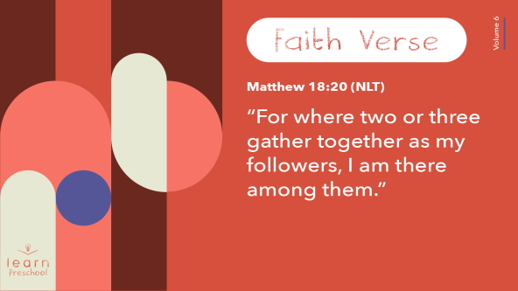

**Matthew** *(hands at waist, spread apart, palms up and out)*

**18:** *(hands together like a clap)*

**20** *(hands opened to “book”)*

**“For where two or three** *(hold up 2 and then 3 fingers)*

**gather together** *(clap hands together and then clasp fingers)*

**as my followers,** *(raise one open hand and then lower palm down)*

**I am there** *(Point up with both index fingers)*

**among them.”** *(sweep arms back and forth at waist level)*

Great job! I love that God promises to be with us when we’re together. He’s right here with us now.

**Closing**

Who learned more about God today? *(Group response)* I’ve had so much fun learning, praying, worshipping, and growing together with you. Our Bible story showed that people have been learning about God and growing together for a long time. It’s so great that we can help others grow and that they can help us.

• *Play the* ***Faith Fact Sound*** *video (bell ringing)*.

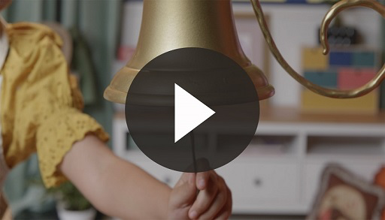

That sound means it’s a great time to practice our Faith Fact again.

• *Show the* ***Faith Fact Slide***.



Let’s pretend to grow again as we say the Faith Fact. Get down low to the ground. Ready? **We grow together**. Now, grow a little taller. **We grow together**. Let’s stand up as tall as we can. **We grow together**.

**Dismissal to Small Groups**

Great job! Now let’s head to our circles and keep learning together.

• *Dismiss the kids by groups*.

|  |
| --- |
| ***Leader Tip:*** *This can be done by assigning color teams or by age groups. Note that some young preschoolers may not know their age. Using a colored sticker, jersey, or wristband will help separate the kids and help identify their small groups.* |

**Small Group**

**25 Minutes**

*See supplies and prep instructions at beginning of session or in each activity below.*

|  |
| --- |
| ***Leader Tip:*** *Small groups can alternate to each circle, or all groups can do each activity at the same time. If you choose to alternate, you will need at least one leader per circle.* |

**Circle 1**

**Group Connection**

**Tall Tower Together**

|  |
| --- |
| ***You Will Need***  *• Blocks of different shapes or colors*  *• Measuring tape*  *• Optional: Painter’s tape*  ***Getting Ready***  *• Optional: Tape a square on the floor to mark the area to keep the blocks in. This will help to keep them from falling on someone or something.* |

When we grow together, we help each other. Today, let’s practice growing together by building a tower of blocks. You’ll each take turns placing a block on the tower. Each time you place a block on top, say our Faith Fact: **We grow together**. When you think our tower is as tall as it can go, we’ll stop and measure it.

• *Give blocks to each kid to let them help build a tower*.

• *Measure it when you run out of blocks or the kids think it’s tall enough*.

Now, let’s knock our tower down together and shout the Faith Fact as loudly as we can. Ready? *(Knock down the tower.)* **We grow together**.

• *When the tower falls, build another one to see if kids can build it higher than the first one*.

Great job! It’s fun to build things by ourself, but it’s so much more fun when we do it together.

**Circle 2**

**Activity Page Time**

**Faith Verse Fun**

|  |
| --- |
| ***You Will Need***  *•* ***Small Group Activity Page****, one per kid*  *• Crayons, markers, or colored pencils*  ***Getting Ready***  *• Print copies of the* ***Small Group Activity Page****, one per kid.* |

Both our Faith Fact and our Faith Verse talk about us being together. Say the Faith Verse with me if you remember it.

[Matthew 18:20](https://ref.ly/logosref/Bible.Mt18.20) (NLT)

“For where two or three gather together as my followers, I am there among them.”

How many people does it say are together in our verse? *(Allow responses.)* That’s right. When there are two or three of us together, God gives us a great promise that He will be with us. Those numbers—one God and two or three people—can help us to remember our Faith Verse.

• *Give each kid a* ***Small Group Activity Page*** *and crayons*.

On your Activity Page, you’ll see those numbers. Practice writing the numbers. Then, color the correct number of pictures in the row for each number.

Why don’t we practice our Faith Verse together before we go to our next circle?

[Matthew 18:20](https://ref.ly/logosref/Bible.Mt18.20) (NLT)

“For where two or three gather together as my followers, I am there among them.”

**Circle 3**

**Feet-to-Floor Game Time**

**Linked Together**

Who’s ready to play a game? *(Group response)* All right! How does our Faith Fact say we grow? *(Group response)* That’s it, together! Let’s play today’s game with a partner.

• *Allow kids to choose a partner or assign partners*.

• *Be ready to play if there is an odd number of kids*.

Now that you have a partner, I’ll give you actions to do. If I say, “Hand to hand,” you’ll touch hands together. If I say, “Foot to foot,” you’ll touch your foot to their foot. When I say, “**We grow together**,” everyone will hold hands and skip in a circle. Ready? Let’s go!

• *Name body parts that kids can touch together: hands, feet, heads, elbows, arms, knees, hips, fingers, etc*.

• *Optional: Let kids suggest actions for everyone to do*.

Great job growing together! You’re such great listeners.

• *During the activity, interrupt and practice the Faith Fact:* **We grow together**.

• *Play the* ***Faith Fact Sound*** *video. Review the Faith Fact even if you can’t play the sound*.



**Circle 4**

**Hands-On Learning**

**Growth Spurt**

|  |
| --- |
| ***You Will Need***  *• Straws with paper wrapper, one per kid*  *• Small bowl of water, one per group*  *• Small paper plates, one per kid*  ***Getting Ready***  *• Optional: Watch this video about the object lesson (*[*https://www.youtube.com/watch?v=mFI0RHvZUUA*](https://www.youtube.com/watch?v=mFI0RHvZUUA)*)* |

Who knows what this is? *(Allow responses.)* Yes! It’s a straw. Did you know that straws can grow? *(Group response)* Well, the straw can’t grow, but we can make the paper wrapper grow. When I open it, I tear the paper at one end and then crinkle the wrapper down until it’s shorter than the straw.

• *Remove the paper wrapper from the straw and leave it crinkled*.

When we make new friends or spend time with other people, we open our life to them like we opened the straw. How do we grow together with our friends and family? *(Allow responses.)* Those are great ideas! Praying together, going to church together, eating together, and worshipping together are great ways the Bible says we can grow together.

When you add water to a plant, it grows. What do you think will happen if I add water to this paper? (*Allow responses.)* Let’s find out! (*Slowly add a few drops of water.)* Wow! It grew! Now who wants to try? *(Group response)*

• *Give each kid a straw and paper plate*.

• *Help kids squish their straw wrapper down, then place it on their paper plate*.

• *Assist kids with getting water in their straw and adding a few drops to their wrapper*.

Every time you see a straw, I want you to remember our Faith Fact: **We grow together**.

**Dismissal**

• *Play the* ***Faith Fact Sound*** *video (bell ringing)*.



• *Show the* ***Faith Fact Slide***.



Perfect timing! Let’s all say our Faith Fact together one more time before we leave. Let’s all get down low and touch the ground. **We grow together***.* Now, jump up as tall as you can and say it. Who’s ready? *(Group response)* Let’s jump. **We grow together**.

• *Send home the* ***Small Group Activity Page*** *with each kid*.

• *Remind parents that there are* ***Family Devotions*** *available on the app to do with their kid*.

• *Tell everyone the date and time for the next session*.